
Brudi & Akontz
Ringstr.17
82152 Krailling

Tel.: 089-752150
Fax: 089-89357788

Brudi & Akontz GbR
- Unternehmensberatung
- Softwareentwicklung
- Marketing

Akontz & Brudi GbR, Ringstr.17, 82152 Krailling

23.03.2015

Dear iSiPRO users,

these are the instructions (Version 18.11.2014) for a download and the installation of the iSiman professionalpackage which consists of iSiPRO (PC) and iSiMobile ( Pocket PC).

Please read this information FIRST and carefully.

If you already have a licence number please save it prior to a new installation

Win 7/8.1 users should install isiman directly under c:\isiman
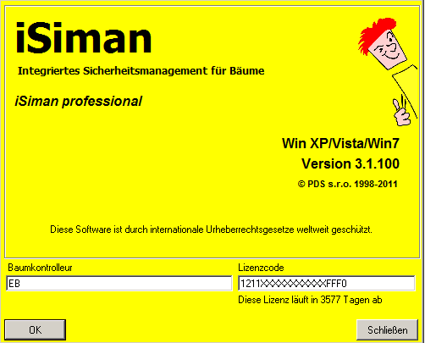

I. Downloads

For new installations please download these components:

Win 7 and 8.1 Users:

1. Isiman Database software

http://download.tree-consult.org/isiman/download/pc_installation/ISIMAN_WIN10/ISIMan_Install.exe

2. Isiman GIS/ 64 bit

http://download.tree-consult.org/isiman/download/pc_installation/TopolNT/TopoLNTSetup.exe

3. Windows Software for using Pocket PC sdf Databases:

1.
https://download.tree-consult.org/isiman/download/pc_installation/SSCERuntime-ENU-x86.msi

2.
https://download.tree-consult.org/isiman/download/pc_installation/SSCERuntime-ENU-x64.msi

Win Vista und Win 7 User, using a 64 bit processor, must download and install both components, whereas 1. (the x86 component) has to be installed first.

4. Dendrology module

https://download.tree-consult.org/isiman/download/pc_installation/4-Dendrola.zip

After download unzip files to: A-treedatabase\dendrola.
After installation please use this update folder:

After the Download unzip files to: c:\program files\pds\isiman und overwrite all existing files.

https://download.tree-consult.org/download/isipro_update/isipro_update.zip

For the Pocket PC with Windows Mobile 5.x or WM 6.this new component is required:

https://download.tree-consult.org/download/isimobile_update/iSiMobile.msi

The isimobile.cab file is being stored on the PPC. Then open file explorer double click on isimobile.cab file and the installation routine sets in. Without license code the trial period in the user level is 60 days.

https://download.tree-consult.org/download/isimobile_update/iSiMobile.CAB

In order to achieve a stable connection between Pc and PPC it is necessary to install „Windows Mobile Device Center“ software from this source (64 bit):

https://www.microsoft.com/de-de/download/details.aspx?id=3182

5. Pocket PC Modul iSiMOBILE

For Pocket PC s running with Windows Mobile 5.x or 6.x this new component is necessary:

https://download.tree-consult.org/download/isimobile_update/iSiMobile.msi

or if you already have a preinstalled version higher than 1.106 you only need to download the self installing .cab file. Copy the isimobile.cab file on your PPC then open the file explorer and click on the isimobile.cab file- the installation starts.

https://download.tree-consult.org/download/isimobile_update/iSiMobile.CAB

To copy files from your PPC to your PC it is necessary that the communication is working. Windows offers the windows mobile device center for this purpose.
You can download it here (for 64 bit systems):

https://www.microsoft.com/de-de/download/details.aspx?id=3182

Since a win 10 update in April 2017 the windows mobile device center is corrupt on many PCs. This tool from trimble should solve the problem:
Seit einem win 10 Update aus dem April 2017 funktioniert bei vielen Rechnern

Just download it and click on it

http://download.tree-consult.org/download/isimobile_update/WMDCRegistryTool.bat
II. Installation

- Create Folder “A_treedatabase“

- Within the folder A_treedatabase create the following sub folders:

- Software
- MasterDB
- Dendrola
- Queries
- Legends
(All Downloads should be saved in the folder “Software”)

During installation admin privileges are required.

- Installation on a home PC (stand alone)

Just install all 4 components- done

- Installation in LANs with different privileges:

  - Installation as Admin
  - Admin gives User temporary admin privileges
  - User registers with admin privileges and installs only iSiman.
  - Admin withdraws admin privileges from user, but allows writing privileges in the folder: c:\program files \pds\isiman and in the folder where the database is located (MasterDB).
After iSiman database software was installed this window pops up:

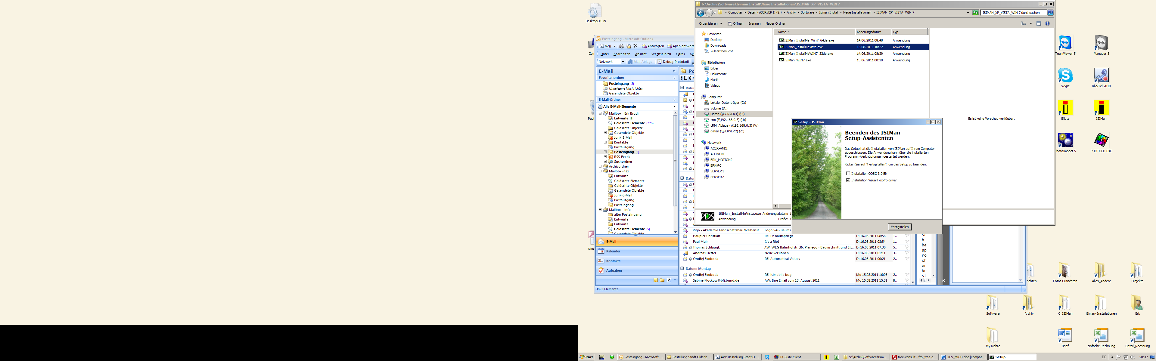
After the Download unzip files to
Please check only the option below
Comments:

To use iSiman it is necessary to have writing privileges in the root directory of isiman (C:\program files (x86)\pds\isiman), this is because all changes (language, path to db, settings) are stored in the initialisation file (isiman.ini). Also the GIS connecting files may be stored in the root directory if the isiman.mdb in the root directory is used.

Writing privileges are also necessary for the folder where the data is being stored.

Win 7/8.1 users should install isiman directly under c:\isiman

Kind Regards

Erk Brudi

